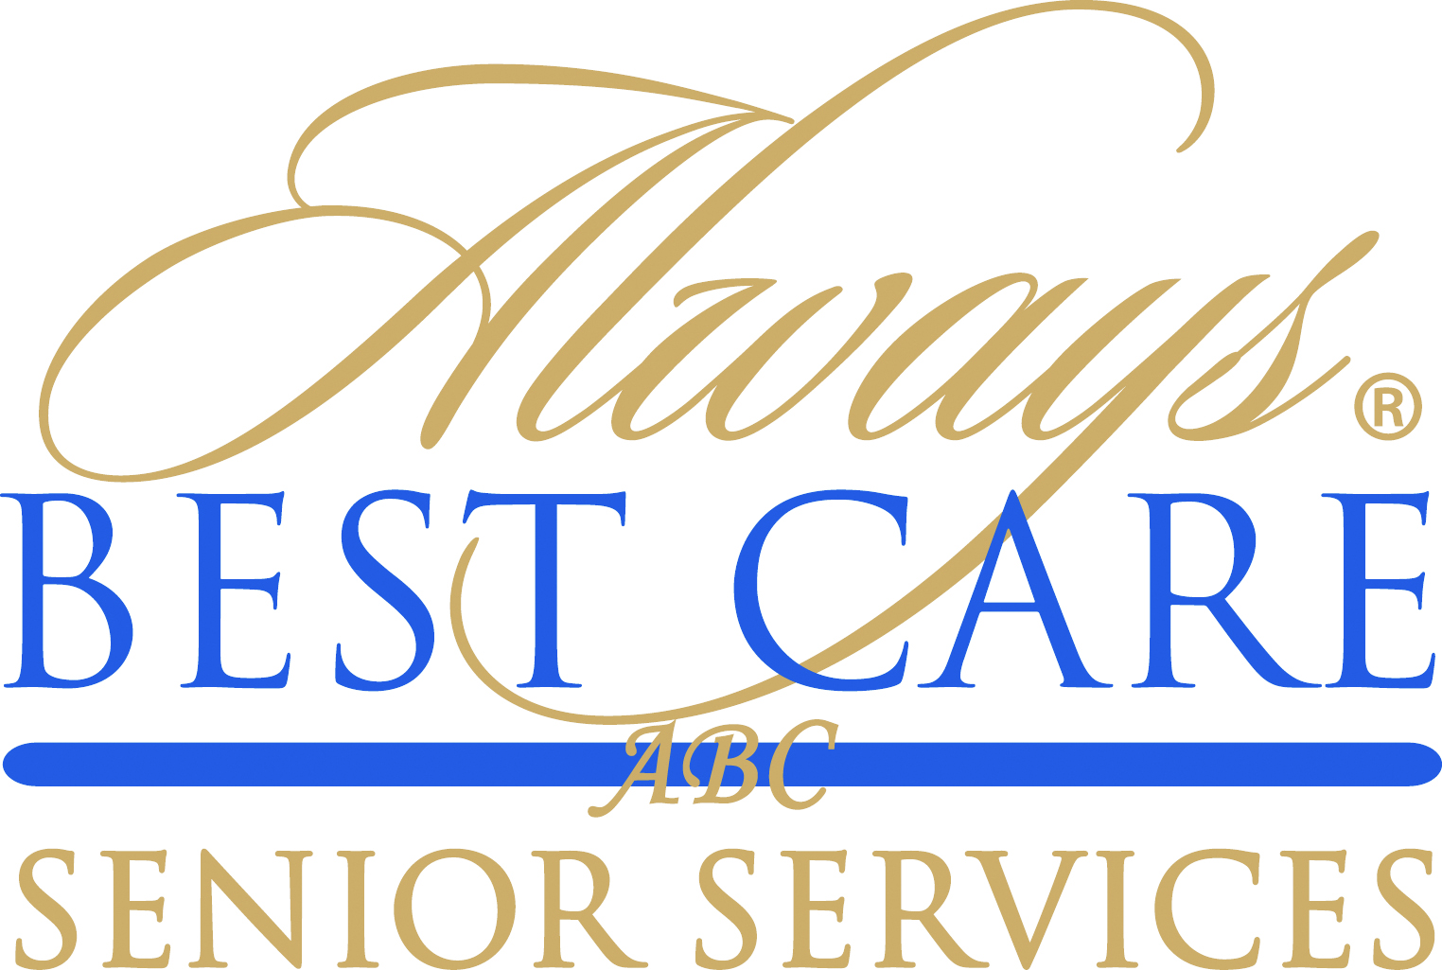

FOR IMMEDIATE RELEASE CONTACT: Larry Miramontes
December 1, 2015 lmiramontes@abc-seniors.com

Answers for Elders Foundation, with Always Best Care Senior Services, Launches Holiday “Goodness” Campaign to Help Millions of Seniors Nationwide Who Are Isolated and Alone
-- NFL and NBA Alumni Visiting Seniors, Delivering Acts of Goodness --
Roseville, CA (December 1, 2015) — For the 40 million Americans 65 and older, the holidays can be an especially difficult time. According to several studies, nearly 60% of seniors who live alone or in care facilities receive no regular visitors.
That’s why the Answers for Elders Foundation, in cooperation with Always Best Care Senior Services, has launched “12 Days of Goodness” in four key U.S. markets and #ActofGoodness, a nationwide social media campaign. Answers for Elders is one of the nation’s leading resources for information, education and service providers for seniors throughout the USA.
Always Best Care is one of the nation’s leading providers of non-medical in-home care, assisted living placement services and skilled home health care. The company delivers its services through an international network of more than 200 independently owned and operated franchise territories throughout the United States.

Now in its second year, the campaign will take place December 12 through December 23 and will help raise awareness for and deliver acts of goodness to America’s seniors throughout the holiday season. The NFL Alumni Association, NFL and NBA Legends will be making appearances in support of the campaign as part of their community service efforts.
In addition, 100% of proceeds from charitable donations will go to support the program and local affiliates of two major charities that serve seniors: Meals on Wheels and Rebuilding Together.
Always Best Care Senior Services has signed on to support the program as its National Diamond Sponsor. One of the nation’s leading providers of non-medical in-home care, assisted living placement services and skilled home health care, Always Best Care delivers its services through an international network of more than 200 independently owned and operated franchise territories throughout the United States. As such it will be providing “boots on the ground” for “12 Days of Goodness.”
“We are very excited to be teaming up with the Answers for Elders Foundation on this wonderful campaign,” said Michael Newman, Founder and Chief Executive Officer of Always Best Care. “Showing love, support and kindness for our seniors, especially during the holidays, is one of the most important things we can do.”
"It's all about getting the fans out to be more aware of seniors who are alone and doing something to help,” said Suzanne Perkins Newman, Founder and Chief Executive Officer of Answers for Elders and creator of 12 Days of Goodness. "I took care of my mom for the last six years of her life and saw the same people sitting alone where she lived, waiting for someone who never comes. Together, we are out to change that over the holiday season."
“12 Days of Goodness” in Denver, Nashville, Philadelphia and Seattle
“12 Days of Goodness” features a variety of grassroots events in four major U.S. cities: Denver, Nashville, Philadelphia and Seattle. In each city, NFL and NBA legends will visit senior communities and participate in activities with seniors ranging from giftwrapping, to holiday parties and events, to formal benefits and fan rallies.
#ActofGoodness National Social Media Campaign
The #ActofGoodness social media campaign is national and designed to encourage viral acts of kindness similar to the recent and wildly popular ice bucket challenge. The participation of the pro legends will help rally sports fans to bring cheer to seniors nationwide.
#ActOfGoodness campaign will start with NFL and NBA alumni performing kind acts for seniors. They will post those on Facebook and then challenge fans and friends to do the same.
The #ActOfGoodness social media campaign is being spearheaded by Joe Tafoya, a fan engagement expert, business entrepreneur and NFL Alumni. Joe is known for the promotion of the Richard Sherman Celebrity Softball Game in Seattle, and also for organizing the successful fan effort in Seattle to break the Guinness book of World Records for the loudest crowd noise, not once, but twice.
To learn more, go to 12DaysOfGoodness.com
# # #
About Answers for Elders
At AnswersForElders.com, we believe that no one should have to experience navigating taking care of your senior loved one feeling alone and unsupported. Let’s face it. We caregivers are living in a daunting world. How do we really know if we are making the right decisions for our parents? There are so many things we face, and yet, if we knew what to prepare for in advance, things wouldn’t be such a crisis every time something happens that we have to step in and make decisions!
AnswersForElders.com was created by Suzanne Perkins Newman, an adult family caregiver walking the same path as close to 45 million adult children in the USA are doing today. In caring for her senior parent, she found resources so limited. She created full eldercare resource service that will support families on the journey. Including a national Care Line, a full online resource portal, and soon to be on its own radio program, Answers for Elders is a resource portal of answers that you need most, not only to learn what the issues are that you need to face, but even more, finding the local businesses that you can work with in your own local community.
The Answers for Elders Foundation is the private foundational arm of Answers for Elders that supports and educates to create new paradigms on how seniors should be treated in the world today. Its mission is to raise the bar on services and standards for those over 65. Currently it supports local affiliates of the Meals on Wheels and Rebuilding Together charities.

About Always Best Care
Founded in 1996, Always Best Care Senior Services is based on the belief that having the right people for the right level of care means peace of mind for the client and family. Always Best Care assists seniors with a wide range of illnesses and personal needs, and currently provides more than 4 million hours of care every year. Franchise opportunities are available to individuals interested in leveraging the company’s clear strategy and proven track record for delivering affordable, dependable service to seniors in their local areas.
By working with case managers, social workers, discharge planners, doctors, and families, Always Best Care franchise owners provide affordable, comprehensive solutions that can be specifically matched to meet a client’s particular physical or social needs. The hallmark services of the Always Best Care business portfolio include non-medical in-home care and assisted living finder and referral services, with skilled home health care now being phased in throughout the country. For more information, visit www.AlwaysBestCare.com. For franchise opportunities, visit www.FranchiseWithAlwaysBestCare.com.
Always Best Care also offers Free ABC Rx cards, which provide discounts of up to 65 percent off the cost of prescription drugs at more than 59,000 pharmacies across the USA, and have saved consumers more than $500,000 since its inception. This service is offered at no cost to the users, there are no deductibles, no waiting periods, no pre-existing exclusions, and no eligibility requirements -- everyone can use the card (even family members and pets!). The Free ABC Rx card covers many medications that Medicare Part D and regular insurance often do not. To download a free card, visit www.FreeABCRx.com.
Another exclusive program offered by Always Best Care is Always in Touch, a telephone reassurance program that provides a daily phone call to seniors and disabled adults who are living alone and have limited contact with the outside world. Always in Touch is the only absolutely free national telephone reassurance program of its kind anywhere in the USA and Canada. For more information on Always in Touch, or to request an application, visit www.Always-in-Touch.com.

